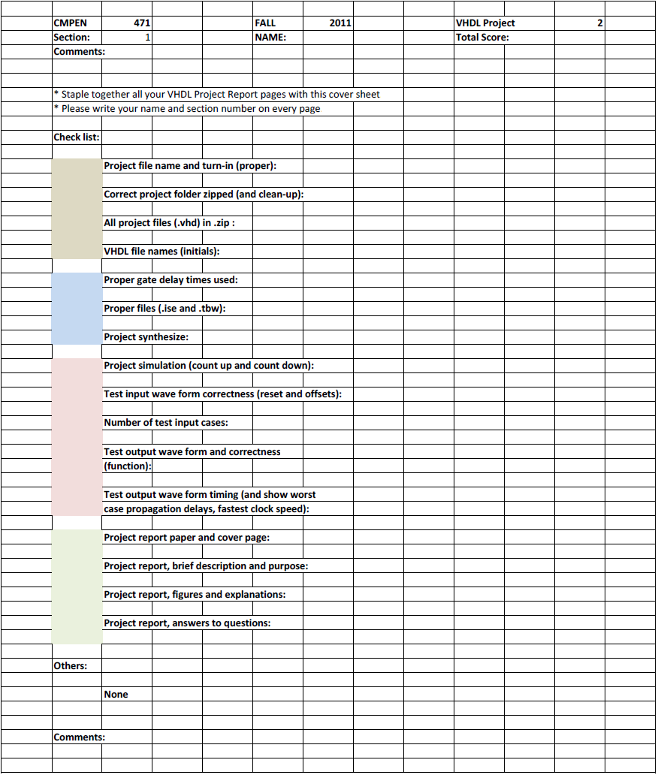
Erik Arfvidson
6

Erik Arfvidson
10/11/2012
Lab6

Project Report6

Purpose and Description

Design, implement, simulate, and debug Simple Microcontroller with 9 instructions and 4 addressing modes. Simply expand project 5 with additional instructions and an I/O unit. You will demonstrate the functionality of your design by writing simple Pulse-Width-Modulation (PWM) program. Simulate the microcontroller executing the program through ISEsim VHDL simulator.
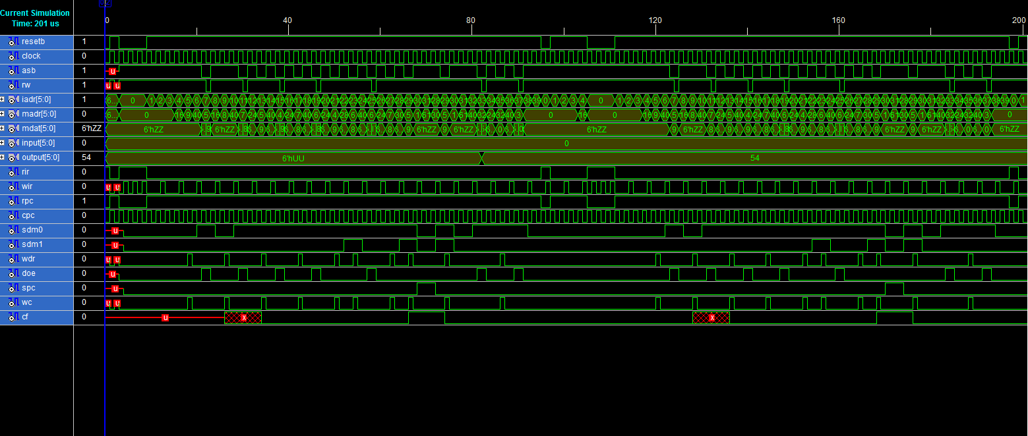

Simulations 1
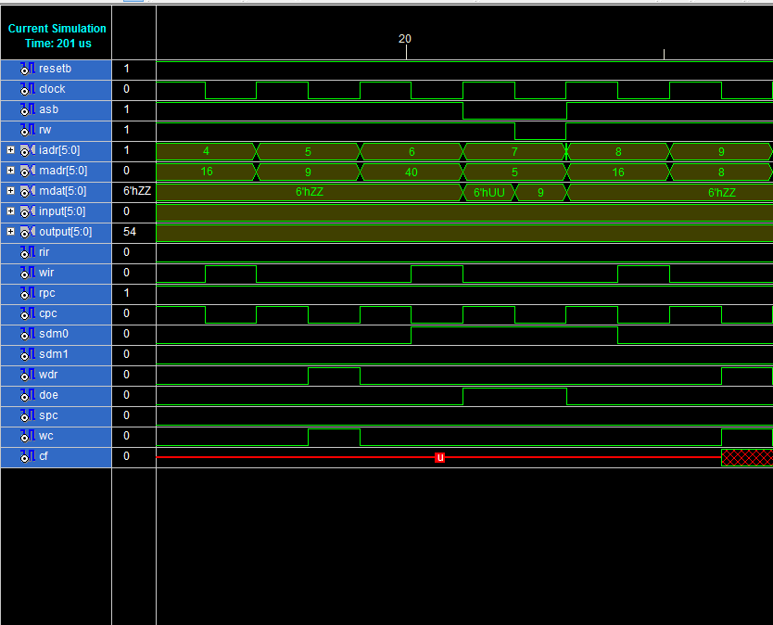

The first command is a load instruction to data register the number 9 followed by a save to memory address 5. The next instruction is a load instruction to data register the number 8.

Simulation 2

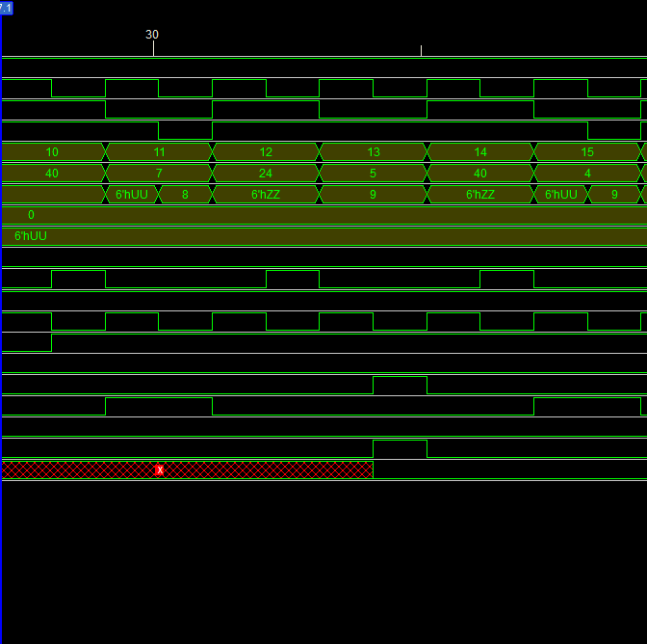

The first instruction in this segment is a store to memory address 7. The next instruction is to load location 5 memory data and the next instruction is to store it to memory location 4

Simulation3

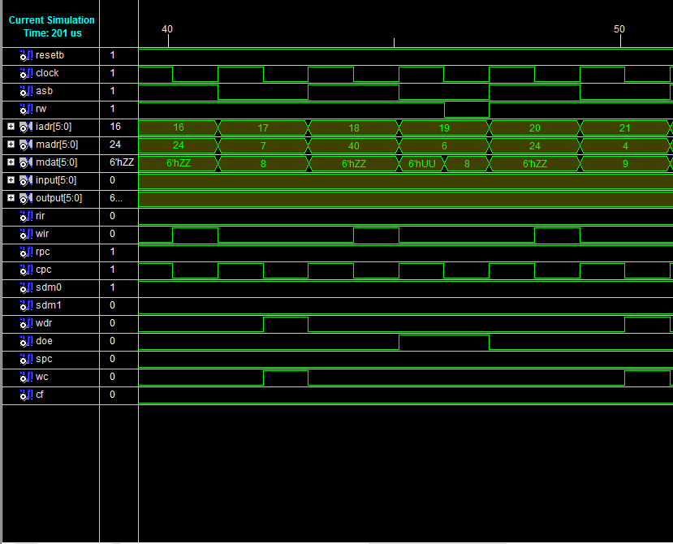
The next instruction is to load location 7 memory data and the next instruction is to store it to memory location 6. The next instruction is and add instruction to add location 6 data to location 4 data and save it to location 6 memory address.

Simulation4
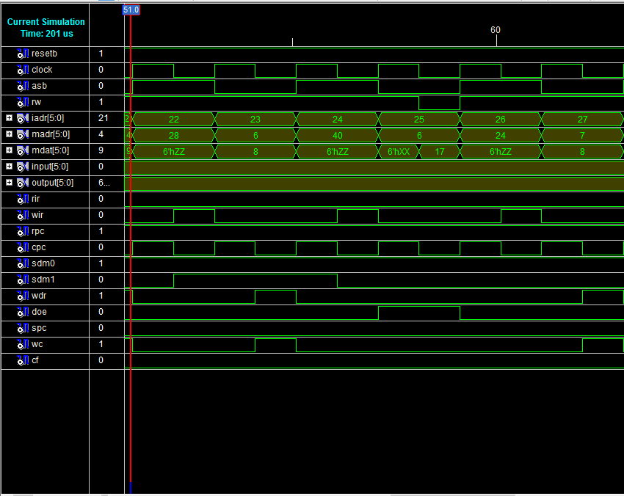 Explained in the previous explanation are the this two instructions and then it is followed by a to read location 7 data to the data register.

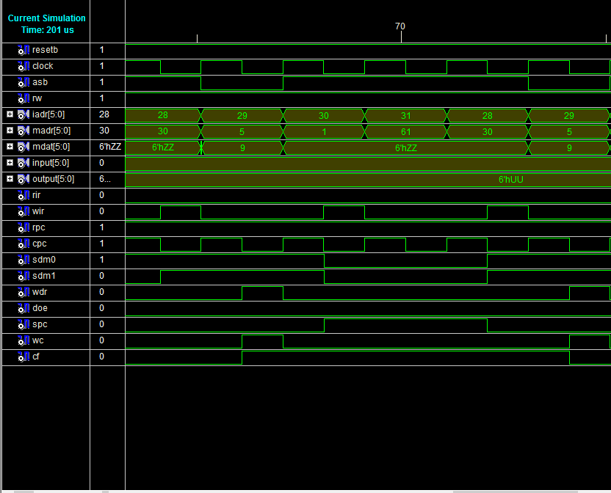
Simulation5
Here the first instruction is subtraction of location 5 data from data register and save answer to DR. Here you also see a branch instruction occur and that is why mdat get unsigned while it starts reading the next instruction that subtract again location 5 data from data register.

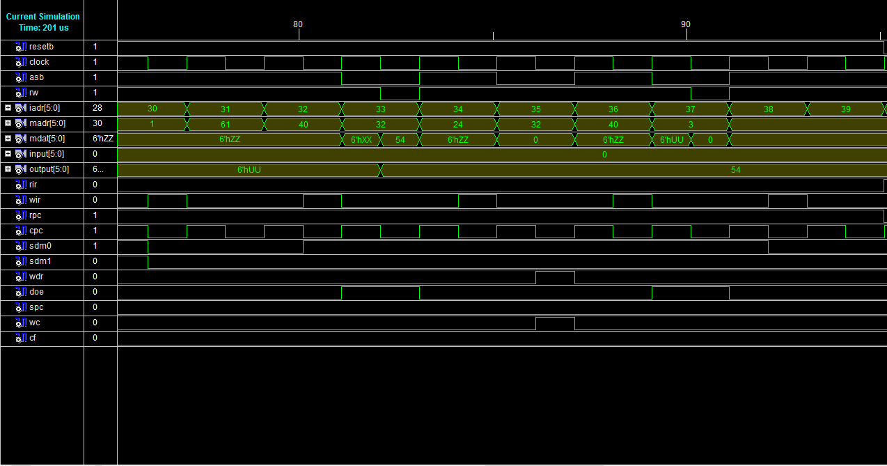
Simulation 6
Is my last simulation here as you can see the program continues as expected after preforming one loop and outputs that’s Data Register to the output port. Finally the input data from the input port and then store it to the location 3.

Testbench1

This is an image of the simulation of test bench1 that Runs program once and then reset and run it again.

The maximum that achieved on my simulation was around 700Mhz before it Started to fail.

